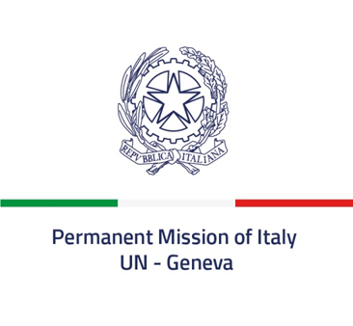

Check against delivery

52nd session of the Human Rights Council
Interactive Dialogue with the SR on the situation of human rights in Afghanistan
6 March 2023
Delivered by Ambassador Vincenzo Grassi, Permanent Representative of Italy to the United Nations in Geneva

Mr. President,

Italy aligns itself with the statement delivered by the European Union and thanks the Special Rapporteur for his report.

Italy remains deeply concerned about the human rights situation in Afghanistan and in particular the violations of women’s and girls’ rights, including their right to education, work and freedom of movement, which represent an unacceptable attempt to erase them from all spheres of public life. The de facto authorities' discriminatory decision to ban women from working in NGOs is a major obstacle to the delivery of basic services, further exacerbating the plight of millions of Afghans already affected by a dire humanitarian crisis. We recall Afghanistan’s international obligations, including under the CEDAW.

The de facto authorities should immediately restore access to education at all levels for women and girls and lift all other discriminatory measures that have an adverse impact on families, communities and the country as a whole, undermining Afghanistan’s capacity to move towards sustainable peace, economic and social development.

Italy is also deeply concerned about the situation of millions of children in Afghanistan deprived of essential services, including primary healthcare, education, water and sanitation, while many of them continue to be killed and maimed by landmines and other explosive remnants of war.

Mr. Special Rapporteur, considering the inclusion in your mandate of a child’s rights perspective, what is your assessment on the situation of children and on future prospects?

I thank you

