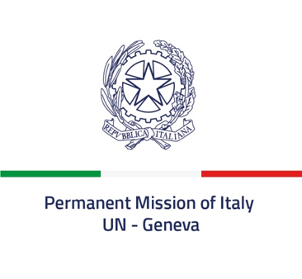

Check against delivery

52nd session of the Human Rights Council
Interactive Dialogue with the SR on the right to food
8 March 2023
Delivered by Ambassador Vincenzo Grassi, Permanent Representative of Italy to the United Nations in Geneva

Mr. President,

Italy aligns itself with the statement delivered by the European Union.

Climate change, the Covid-19 pandemic, international geopolitical and financial instability, the loss of biodiversity are severely impacting on food security and the right to have access to sustainable, safe, and nutritious food. Russia’s war of aggression has further aggravated the global food crisis.

Against this backdrop, Italy is playing in many ways a prominent role for the definition of a food security strategy, also in order to contribute to the implementation of the 2030 Agenda.

The Matera Declaration, adopted during the Italian G20 Presidency, recognized for the first time that food security is a priority of the international agenda.

In response to the food crisis caused by the war in Ukraine, Italy made efforts – in the framework of the G7 – to address its impact in the Mediterranean region, launching the Mediterranean Ministerial Dialogue on the Food Crisis.

In the context of the UN Food Systems Summit, whose coordination hub is located at FAO’s premises, Italy hosted the pre-Summit in Rome in 2021 and next July will host again in Rome the Food Systems Summit Stocktaking Moment, high-profile event convened by Secretary General Guterres to take an initial stock of the progress of the transformation of food systems and to inspire a new form of global momentum and solidarity.

I thank you

