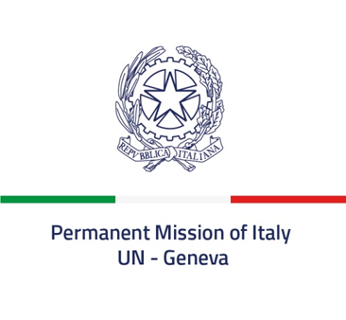 *Check against delivery*

**53rd session of the Human Rights Council**

**Item 3**

**Interactive Dialogue with the Special Rapporteur on the right of everyone to the enjoyment of the highest attainable standard of physical and mental health**

*22 June 2023*

**Delivered by Ambassador Vincenzo Grassi,**

**Permanent Representative of Italy to the United Nations in Geneva**

*Mr. President,*

Italy aligns itself with the statement delivered by the European Union and thanks the Special Rapporteur for her report.

The COVID-19 pandemic has accelerated the rise of digital health, highlighting the contribution of digital innovation and technologies to the realization of the right to physical and mental health. In this regard, Italy is committed to promote digital technologies in health systems in order to improve global health and achieve universal health coverage through a human rights-based approach.

Digital transition is also one of the pillars of our National Recovery and Resilience Plan, and will involve our healthcare system with a view to provide equal access to health services for all. Italy is in fact engaged in promoting new telemedicine projects for remote assistance and in enhancing the implementation of the electronic health records, while fostering the protection of personal data and the right to privacy.

Digital innovation and technologies are an asset to realize the right to health, but their use implies the need to ensure accessibility and to address the digital divide, especially for women and girls who can benefit from technology and digital tools to make informed decisions regarding their sexual and reproductive health and rights.

The respect of the principles of equality, non-discrimination, participation and transparency is crucial to fulfil the right to health in relation to digital innovation and technologies, so to advance the Sustainable Development Goals and to make sure that that no one is left behind.

*I thank you*