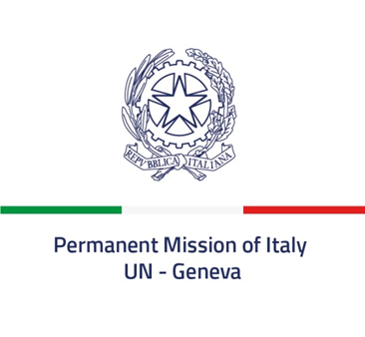 *Check against delivery*

**53rd session of the Human Rights Council**

**Item 3**

**Interactive Dialogue with the Special Rapporteur**

**on violence against women, its causes and consequences**

*23 June 2023*

**Delivered by Ambassador Vincenzo Grassi,**

**Permanent Representative of Italy to the United Nations in Geneva**

*Mr. President,*

Italy aligns itself with the statement delivered by the European Union and thanks the Special Rapporteur for her presentation.

Violence against women and girls is a blatant and deplorable violation of human rights, which is unfortunately widespread without any geographical, generational or social distinction. Significant efforts have been made in recent decades to identify, eradicate and prevent it in all its forms. However, for too many women and girls, a life free from violence is still not a reality.

At national level, in 2019 Italy adopted a law on gender-based violence and domestic violence, known as “Red Code”, which places protection of victims and survivors at the centre and that is currently being updated in order to strengthen prevention mechanisms and response. The National Strategic Plan for the period 2021-2023 also includes measures aimed at enhancing training and education of professionals, awareness-raising and assistance through a comprehensive approach.

At international level, Italy supports the ratification and the implementation of the Council of Europe Convention on Preventing and Combating Violence against Women and Domestic Violence, as well as initiatives for the prevention of sexual violence in conflicts and emergencies.

We therefore condemn all forms of discrimination and violence against women and girls, and confirm our engagement in preserving and promoting women’s rights, gender equality and women’s empowerment, to advance SGD 5 of the 2030 Agenda for Sustainable Development.

*I thank you*