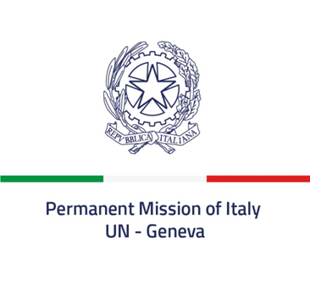

Check against delivery

53rd session of the Human Rights Council
Interactive dialogue with the Independent International Fact-Finding Mission
on the Islamic Republic of Iran
5 July 2023

Delivered by Ambassador Vincenzo Grassi, Permanent Representative of Italy
to the United Nations in Geneva

Mr. President,

Italy aligns itself with the statement delivered by the European Union and thanks the Fact-Finding Mission for the oral update.

Italy condemns in the strongest terms the practice of imposing and carrying out death sentences against protesters. We reiterate our firm opposition against the application of capital punishment in any circumstance and call on Iran to refrain from any future executions and to pursue a consistent policy towards the abolition of death penalty.

We remain concerned about the deteriorated human rights situation in Iran, especially with respect to women and children. We deplore the continued restrictions to civic and democratic space, the widespread resort to arbitrary detentions, the disproportionate use of force by security forces, and the use of torture and other cruel, inhuman and degrading treatments.

We call on Iran to ensure the full enjoyment of human rights and fundamental freedoms, including the rights to freedom of expression and peaceful assembly, as well as accountability and justice for all victims.

We urge Iran to end all forms of systemic discrimination against women and girls, and to prevent and ensure their protection against sexual and gender-based violence in all its forms. Discrimination in law and in practice against persons belonging to ethnic, religious and linguistic minorities must be eliminated.

I thank you

